Reiki – Level 1 Training
Gain a lasting connection to Reiki
Date: Sat/Sun. Sept. 5th and 6th, 2020
Time: 12:00-3:00 each day.
Place: Pick a cozy couch or chair and join via ZOOM for this comprehensive, enlightening, certification training.

Included in this training:
- Comprehensive level 1 manual and education about Reiki
- Level 1 attunement
- Practice and training to be able to perform Reiki sessions on yourself, family or friends.
- A certificate of completion
- We will take short breaks throughout

**This group is appropriate for anyone interested in learning about Reiki and/or being certified for Level 1, regardless of location.
Registration and payment information
- Energy exchange (Reiki term for payment):
  - Total = $225.00
  - Non-refundable $40 deposit due at registration, balance due by 9/5
- Click here to register and pay: Reiki class registration

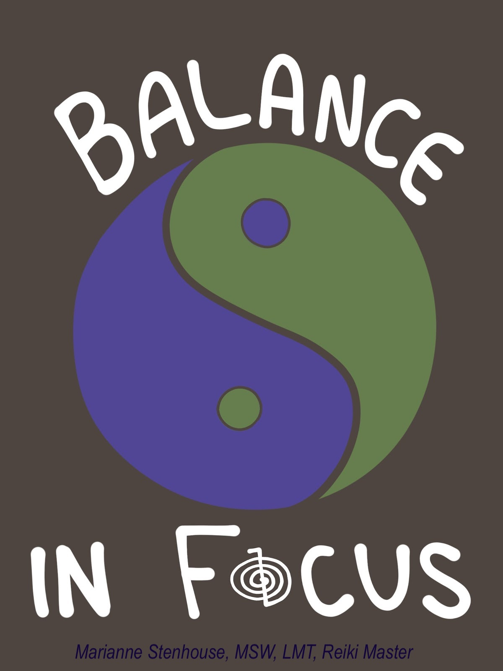
For more information contact:

Marianne Stenhouse, MSW, LMT, Reiki Master
Email: Maristenhouse@gmail.com
Phone: 720-564-6283
Website: https://balanceinfocus.com/

